Milestone_3

Martha Wetzel

4/26/2018

# Results

## Descriptive Statistics

The tables below provide descriptive statistics for key demographic variables.

Gender By PDMP Policy

|  |  |  |  |
| --- | --- | --- | --- |
|  | No PDMP | Optional PDMP | Mandatory PDMP |
| Male | 272365 | 794722 | 52783 |
| Female | 415570 | 1156903 | 83114 |

Health Status By PDMP Policy

|  |  |  |  |
| --- | --- | --- | --- |
|  | No PDMP | Optional PDMP | Mandatory PDMP |
| Excellent | 120205 | 344880 | 20684 |
| Very good | 225364 | 633742 | 41911 |
| Good | 212263 | 595512 | 42460 |
| Fair | 90068 | 259008 | 20940 |
| Poor | 37468 | 111305 | 9459 |

Education By PDMP Policy

|  |  |  |  |
| --- | --- | --- | --- |
|  | No PDMP | Optional PDMP | Mandatory PDMP |
| Never attended | 823 | 2542 | 145 |
| Grades 1 through 8 | 17172 | 53227 | 3970 |
| Grades 9 through 11 | 38364 | 110482 | 8430 |
| Grade 12 or GED | 209685 | 552065 | 43751 |
| Some College | 182453 | 533892 | 34682 |
| College 4 years or more | 236698 | 689885 | 44118 |

The following figures illustrate the distribution of focal outcomes. Both the outcomes of days where physical health was not good and days where activity was limited due to poor health had a range of 0 - 30. Figures 1 and 2 show days of not good physical health. The distribution was similar between the optional and mandatory PDMPs. In both cases, the distribution was bimodal. Due to this distribution, outcomes were recoded as binary variables indicating the individual spent more than half of the preceeding 30 days in poor physical health.

`stat_bin()` using `bins = 30`. Pick better value with `binwidth`.

Warning: Removed 63450 rows containing non-finite values (stat_bin).

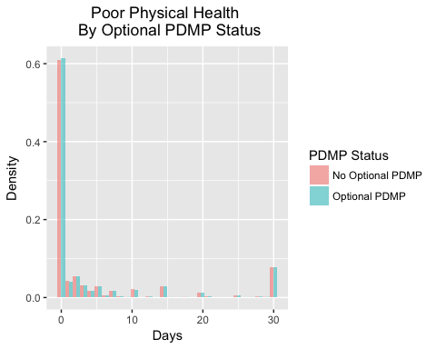

`stat_bin()` using `bins = 30`. Pick better value with `binwidth`.

Warning: Removed 63450 rows containing non-finite values (stat_bin).

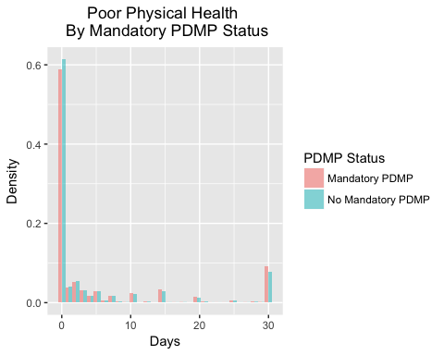

Similar to the days of poor physical health, the days of activity limitations outcome also showed a bimodal distribution. There was a small difference visible for the mandatory vs. not mandatory PDMP distribution, but overall the distributions were very similar. This variable was also recoded to be a binary indicator representing individuals who reported having activity limitations for more than half the days of the month.

`stat_bin()` using `bins = 30`. Pick better value with `binwidth`.

Warning: Removed 1369220 rows containing non-finite values (stat_bin).

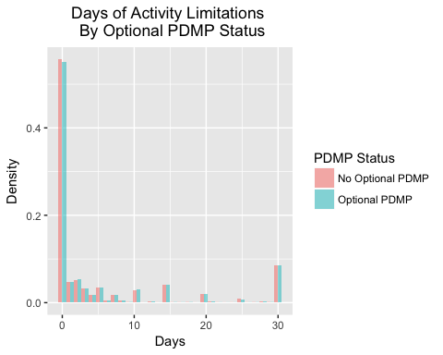

`stat_bin()` using `bins = 30`. Pick better value with `binwidth`.

Warning: Removed 1369220 rows containing non-finite values (stat_bin).

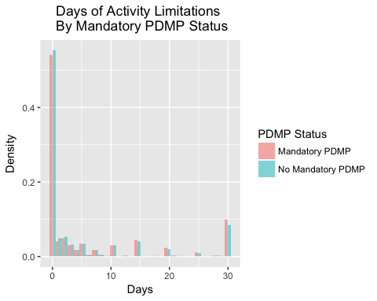

## Regression Results

=============================================================================  
 Dependent variable:   
 ---------------------------  
 Employed   
-----------------------------------------------------------------------------  
PostOptPDMP 0.986**   
 (0.006)   
   
PostMandPDMP 0.995   
 (0.013)   
   
GenHealthFacVery good 0.890***   
 (0.004)   
   
GenHealthFacGood 0.670***   
 (0.003)   
   
GenHealthFacFair 0.337***   
 (0.002)   
   
GenHealthFacPoor 0.114***   
 (0.001)   
   
MEDCOST_cln 0.728***   
 (0.004)   
   
Race_clnBlack 0.580***   
 (0.003)   
   
Race_clnAIAN 0.632***   
 (0.007)   
   
Race_clnAsian 1.060***   
 (0.015)   
   
Race_clnNative Hawaiian or other Pacific Islander 0.814***   
 (0.022)   
   
Race_clnOther 0.896***   
 (0.011)   
   
FEMALEFemale 1.113***   
 (0.004)   
   
Age 0.916***   
 (0.0001)   
   
EDUCA_clnGrades 1 through 8 0.687***   
 (0.034)   
   
EDUCA_clnGrades 9 through 11 0.454***   
 (0.022)   
   
EDUCA_clnGrade 12 or GED 0.648***   
 (0.031)   
   
EDUCA_clnSome College 0.721***   
 (0.035)   
   
EDUCA_clnCollege 4 years or more 0.878***   
 (0.043)   
   
SMOKE100_cln 0.729***   
 (0.002)   
   
year_char2011 0.932***   
 (0.005)   
   
year_char2012 0.966***   
 (0.006)   
   
year_char2013 0.925***   
 (0.005)   
   
year_char2014 0.924***   
 (0.006)   
   
year_char2015 0.906***   
 (0.006)   
   
StatecodeAL 0.638***   
 (0.014)   
   
StatecodeAR 0.795***   
 (0.019)   
   
StatecodeAZ 0.682***   
 (0.015)   
   
StatecodeCA 0.732***   
 (0.015)   
   
StatecodeCO 0.913***   
 (0.019)   
   
StatecodeCT 0.900***   
 (0.019)   
   
StatecodeDC 0.912***   
 (0.023)   
   
StatecodeDE 0.770***   
 (0.018)   
   
StatecodeFL 0.661***   
 (0.013)   
   
StatecodeGA 0.798***   
 (0.018)   
   
StatecodeHI 0.884***   
 (0.020)   
   
StatecodeIA 1.030   
 (0.023)   
   
StatecodeID 0.855***   
 (0.019)   
   
StatecodeIL 0.964   
 (0.022)   
   
StatecodeIN 0.896***   
 (0.019)   
   
StatecodeKS 0.941***   
 (0.019)   
   
StatecodeKY 0.736***   
 (0.016)   
   
StatecodeLA 0.893***   
 (0.020)   
   
StatecodeMA 0.823***   
 (0.016)   
   
StatecodeMD 0.970   
 (0.020)   
   
StatecodeME 0.832***   
 (0.017)   
   
StatecodeMI 0.723***   
 (0.015)   
   
StatecodeMN 0.991   
 (0.020)   
   
StatecodeMO 0.796***   
 (0.018)   
   
StatecodeMS 0.780***   
 (0.017)   
   
StatecodeMT 0.994   
 (0.021)   
   
StatecodeNC 0.721***   
 (0.015)   
   
StatecodeND 1.367***   
 (0.031)   
   
StatecodeNE 1.304***   
 (0.026)   
   
StatecodeNH 0.837***   
 (0.019)   
   
StatecodeNJ 0.905***   
 (0.018)   
   
StatecodeNM 0.859***   
 (0.018)   
   
StatecodeNV 0.696***   
 (0.017)   
   
StatecodeNY 0.818***   
 (0.018)   
   
StatecodeOH 0.825***   
 (0.018)   
   
StatecodeOK 0.963*   
 (0.021)   
   
StatecodeOR 0.663***   
 (0.015)   
   
StatecodePA 0.835***   
 (0.017)   
   
StatecodeRI 0.751***   
 (0.017)   
   
StatecodeSC 0.778***   
 (0.016)   
   
StatecodeSD 1.205***   
 (0.026)   
   
StatecodeTN 0.658***   
 (0.015)   
   
StatecodeTX 0.939***   
 (0.019)   
   
StatecodeUT 1.067***   
 (0.022)   
   
StatecodeVA 0.971   
 (0.021)   
   
StatecodeVT 1.043*   
 (0.023)   
   
StatecodeWA 0.717***   
 (0.014)   
   
StatecodeWI 0.907***   
 (0.021)   
   
StatecodeWV 0.764***   
 (0.017)   
   
StatecodeWY 1.010   
 (0.022)   
   
Constant 694.815***   
 (36.549)   
   
-----------------------------------------------------------------------------  
Observations 2,629,595   
Log Likelihood -1,257,063.000   
Akaike Inf. Crit. 2,514,279.000   
=============================================================================  
Note: *p<0.1; **p<0.05; ***p<0.01

==============================================================================  
 Dependent variable:   
 ----------------------------  
 BadPhys_Bin Limited_bin   
 (1) (2)   
------------------------------------------------------------------------------  
PostOptPDMP 1.001 1.004   
 (0.010) (0.011)   
   
PostMandPDMP 1.016 0.986   
 (0.020) (0.022)   
   
GenHealthFacVery good 1.786*** 1.188***   
 (0.025) (0.020)   
   
GenHealthFacGood 5.058*** 2.786***   
 (0.065) (0.044)   
   
GenHealthFacFair 30.178*** 9.064***   
 (0.389) (0.143)   
   
GenHealthFacPoor 221.225*** 33.619***   
 (3.132) (0.549)   
   
MEDCOST_cln 1.564*** 1.561***   
 (0.010) (0.010)   
   
Race_clnBlack 0.803*** 0.949***   
 (0.007) (0.009)   
   
Race_clnAIAN 1.067*** 1.134***   
 (0.016) (0.019)   
   
Race_clnAsian 0.556*** 0.669***   
 (0.013) (0.019)   
   
Race_clnNative Hawaiian or other Pacific Islander 0.688*** 0.766***   
 (0.027) (0.034)   
   
Race_clnOther 0.815*** 0.922***   
 (0.013) (0.017)   
   
FEMALEFemale 1.232*** 1.017***   
 (0.006) (0.006)   
   
Age 1.010*** 1.003***   
 (0.0002) (0.0002)   
   
EDUCA_clnGrades 1 through 8 1.224*** 1.239***   
 (0.075) (0.088)   
   
EDUCA_clnGrades 9 through 11 1.451*** 1.471***   
 (0.088) (0.103)   
   
EDUCA_clnGrade 12 or GED 1.463*** 1.356***   
 (0.089) (0.095)   
   
EDUCA_clnSome College 1.652*** 1.446***   
 (0.100) (0.101)   
   
EDUCA_clnCollege 4 years or more 1.401*** 1.201***   
 (0.085) (0.084)   
   
SMOKE100_cln 1.260*** 1.366***   
 (0.006) (0.008)   
   
year_char2011 1.013* 1.027***   
 (0.008) (0.009)   
   
year_char2012 1.031*** 1.042***   
 (0.009) (0.010)   
   
year_char2013 1.030*** 1.058***   
 (0.009) (0.011)   
   
year_char2014 1.040*** 1.086***   
 (0.010) (0.012)   
   
year_char2015 1.084*** 1.131***   
 (0.010) (0.012)   
   
StatecodeAL 1.042 1.205***   
 (0.034) (0.044)   
   
StatecodeAR 1.007 1.115***   
 (0.035) (0.044)   
   
StatecodeAZ 1.068** 1.173***   
 (0.035) (0.044)   
   
StatecodeCA 1.135*** 1.231***   
 (0.035) (0.044)   
   
StatecodeCO 1.064** 1.028   
 (0.034) (0.037)   
   
StatecodeCT 1.052 1.041   
 (0.035) (0.040)   
   
StatecodeDC 1.075* 1.211***   
 (0.043) (0.054)   
   
StatecodeDE 1.073* 1.120***   
 (0.039) (0.047)   
   
StatecodeFL 1.127*** 1.216***   
 (0.034) (0.041)   
   
StatecodeGA 1.047 1.117***   
 (0.035) (0.043)   
   
StatecodeHI 1.061 1.208***   
 (0.038) (0.050)   
   
StatecodeIA 0.928** 1.001   
 (0.032) (0.040)   
   
StatecodeID 1.121*** 1.186***   
 (0.039) (0.046)   
   
StatecodeIL 0.976 0.934*   
 (0.035) (0.038)   
   
StatecodeIN 1.003 1.036   
 (0.032) (0.038)   
   
StatecodeKS 0.917*** 0.992   
 (0.028) (0.035)   
   
StatecodeKY 1.093*** 1.197***   
 (0.036) (0.044)   
   
StatecodeLA 0.914*** 1.065*   
 (0.030) (0.040)   
   
StatecodeMA 1.147*** 1.270***   
 (0.035) (0.044)   
   
StatecodeMD 1.028 1.068*   
 (0.033) (0.039)   
   
StatecodeME 1.182*** 1.257***   
 (0.038) (0.046)   
   
StatecodeMI 1.107*** 1.202***   
 (0.035) (0.044)   
   
StatecodeMN 0.949* 1.027   
 (0.030) (0.037)   
   
StatecodeMO 1.076** 1.258***   
 (0.036) (0.048)   
   
StatecodeMS 0.887*** 1.087**   
 (0.029) (0.041)   
   
StatecodeMT 1.084** 1.143***   
 (0.035) (0.043)   
   
StatecodeNC 1.004 1.121***   
 (0.032) (0.041)   
   
StatecodeND 0.844*** 0.806***   
 (0.030) (0.034)   
   
StatecodeNE 0.875*** 0.947   
 (0.027) (0.034)   
   
StatecodeNH 1.140*** 1.195***   
 (0.039) (0.047)   
   
StatecodeNJ 1.012 1.082**   
 (0.032) (0.039)   
   
StatecodeNM 1.092*** 1.143***   
 (0.035) (0.042)   
   
StatecodeNV 1.121*** 1.056   
 (0.041) (0.044)   
   
StatecodeNY 1.092*** 1.120***   
 (0.037) (0.043)   
   
StatecodeOH 1.084** 1.175***   
 (0.036) (0.045)   
   
StatecodeOK 1.037 1.292***   
 (0.033) (0.047)   
   
StatecodeOR 1.222*** 1.262***   
 (0.042) (0.050)   
   
StatecodePA 1.113*** 1.113***   
 (0.035) (0.041)   
   
StatecodeRI 1.196*** 1.280***   
 (0.041) (0.050)   
   
StatecodeSC 1.047 1.154***   
 (0.033) (0.041)   
   
StatecodeSD 0.862*** 0.880***   
 (0.029) (0.035)   
   
StatecodeTN 1.052 1.319***   
 (0.036) (0.051)   
   
StatecodeTX 0.896*** 0.981   
 (0.028) (0.035)   
   
StatecodeUT 1.120*** 1.088**   
 (0.036) (0.040)   
   
StatecodeVA 1.002 1.054   
 (0.034) (0.041)   
   
StatecodeVT 1.194*** 1.215***   
 (0.041) (0.048)   
   
StatecodeWA 1.115*** 1.195***   
 (0.034) (0.042)   
   
StatecodeWI 1.083** 1.093**   
 (0.038) (0.044)   
   
StatecodeWV 1.055 1.208***   
 (0.035) (0.046)   
   
StatecodeWY 0.997 1.002   
 (0.035) (0.040)   
   
Constant 0.005*** 0.016***   
 (0.0003) (0.001)   
   
------------------------------------------------------------------------------  
Observations 2,575,182 1,337,057   
Log Likelihood -641,765.700 -461,079.600   
Akaike Inf. Crit. 1,283,683.000 922,311.300   
==============================================================================  
Note: *p<0.1; **p<0.05; ***p<0.01